

**Sampling Distribution and Estimation**

**Lab: 1 Date: 2080/02/29**

**Project 1.1: For Ungrouped Data**

**OBJECT:**

ENTER THE FOLLOWING VALUES IN SPSS AND CALCULATE MEAN, S.D, RANGES, MODE, MEDIAN

WEIGHTS: 25, 35, 45, 55, 65, 75

**WORKING EXPRESSIONS:**

We have,

1. Mean (X) = $\frac{\sum{x}}{n}$
2. Median (Md) = $\frac{n+1}{2}$
3. Standard Deviation (S.D.) = $\sqrt{\frac{∑(X-X̅)2}{n}}$
4. Range = max – min
5. Mode = maximum repetition of data
6. Standard error (S.E.) =

Note: Where represents the sum of all the items in the dataset and n represent the number of items in the given dataset.

**PROCESS:**

Solution:

1. Select **Analyze Descriptive statistics Descriptives**
2. Click the **Descriptives** Move **Midvalue** into **Variables(s).**
3. Click the **Option**. Select **Mean, s.d., ranges, mode, median**
4. Click **Ok**

**CALCULATION:**

From SPSS,

MEAN, S.D, RANGES, MODE, MEDIAN FROM THE GIVEN DATA IS SHOWN THROUGH THE TABLE

|  |  |  |
| --- | --- | --- |
| **Statistics** | | |
| Weights | | |
| N | Valid | 6 |
| Missing | 0 |
| Mean | | 49.83 |
| Std. Error of Mean | | 7.705 |
| Median | | 50.00 |
| Mode | | 25a |
| Std. Deviation | | 18.872 |
| Variance | | 356.167 |
| Range | | 50 |
| Minimum | | 25 |
| Maximum | | 75 |
|  | | |

**RESULT:**

From the above table, the following results were obtained:

1. Average of the given data (Mean) = 49.83
2. Median = 50.00
3. Standard Deviation (S.D.)= 18.872
4. Range of a weight = 50
5. Mode = 25 (Multiple modes exists. The smallest value is shown)

**CONCLUSION:**

Mean, standard deviation, mode, median and range were obtained using SPSS



**Sampling Distribution and Estimation**

**Lab: 1 Date: 2080/02/29**

**Project 1.2: For Ungrouped Data**

**OBJECT:**

ENTER THE FOLLOWING VALUES IN SPSS AND CALCULATE MEAN, S.D, RANGES, MODE, MEDIAN

|  |  |  |
| --- | --- | --- |
| WEIGHT | MID VALUE | FREQUENCY |
| 20-30 | 25 | 4 |
| 30-40 | 35 | 6 |
| 40-50 | 45 | 7 |
| 50-60 | 55 | 21 |
| 60-70 | 65 | 23 |
| 70-80 | 75 | 2 |

**WORKING EXPRESSIONS:**

We have,

1. Mean (X) =
2. Median (Md) =
3. Standard Deviation (S.D.) =
4. Range = max – min
5. Mode = maximum repetition of data
6. Standard error (S.E.) =

Note: Where represents the sum of all the items in the dataset and n represent the number of items in the given dataset.

**PROCESS:**

Solution:

1. Enter the **Data Editor Window**.
2. Select **Data** **Weight Cases.**
3. Move **Frequency** into **Frequency Variable**
4. Click **Ok.** Select **Analyze** **Descriptive statistic** **Frequencies**
5. Click the **frequencies** Move **MidValue** into **Variable(s)**
6. Click the **Statistics.** Select **Mean.**
7. Click **Continue.** Click **Ok.**

**CACLUCATION:**

From SPSS,

|  |  |  |
| --- | --- | --- |
| **Statistics** | | |
| Mid_value | | |
| N | Valid | 63 |
| Missing | 0 |
| Mean | | 54.37 |
| Median | | 55.00 |
| Mode | | 65 |
| Std. Deviation | | 12.556 |
| Range | | 50 |

**RESULT:**

From the SPSS output table, the following results are obtained:

1. Mean = 54.37
2. Median = 55.00
3. Mode = 65
4. Standard Deviation (S.D) = 12.556
5. Range = 50

**CONCLUSION:**

Mean, standard deviation, mode, median and range were obtained using SPSS



**Sampling Distribution and Estimation**

**Lab: 1 Date: 2080/02/29**

**Project 1.3: ENTER THE FOLLOWING DATA IN SPSS**

**OBJECT: GIVEN DATA IS:**

|  |  |  |
| --- | --- | --- |
| WEIGHT | MID VALUE | FREQUENCY |
| 20-30 | 25 | 4 |
| 30-40 | 35 | 6 |
| 40-50 | 45 | 7 |
| 50-60 | 55 | 21 |
| 60-70 | 65 | 23 |
| 70-80 | 75 | 2 |

**WORKING EXPRESSIONS:**

We have,

1. Mean (X) =
2. Median (Md) =
3. Standard Deviation (S.D.) =
4. Range = max – min
5. Mode = maximum repetition of data
6. Standard error (S.E.) =

Note: Where $\sum{x}$ represents the sum of all the items in the dataset and n represent the number of items in the given dataset.

**PROCESS:**

In this task, we will create four types of variables: Numeric, data, string and binary.

1. Click the **Type in data tab.**
2. Click the **Variable View** tab at the bottom of the window.
3. With the cursor in the Name column on the first row type: **Weight,** on the second row type: **Midvalue,** on the third row type: **Frequency.**
4. In the Type column, click the **Numeric** to open the Variable Type dialog box.
5. Select (Click) **String.**
6. Click **Ok.**
7. Press tab or Enter three times to move to **label column.**
8. Type “The weight of 63 students of a school”.
9. Click the **Data View** tab at the bottom of the window.
10. Enter the values as follows. Then save file.

**RESULT:**

After following above process, following results were seen:

Variable View:

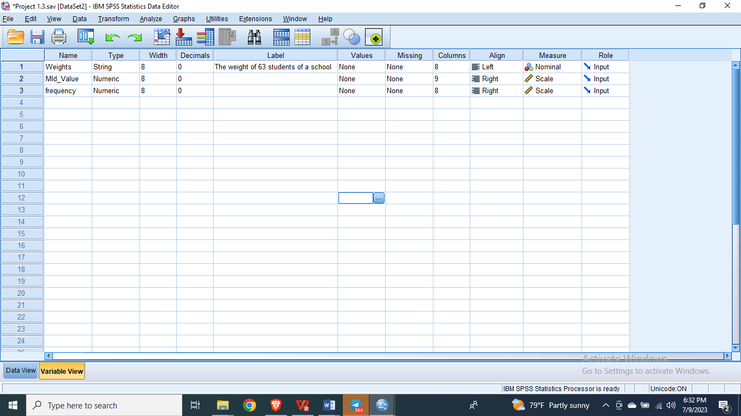

Data View:

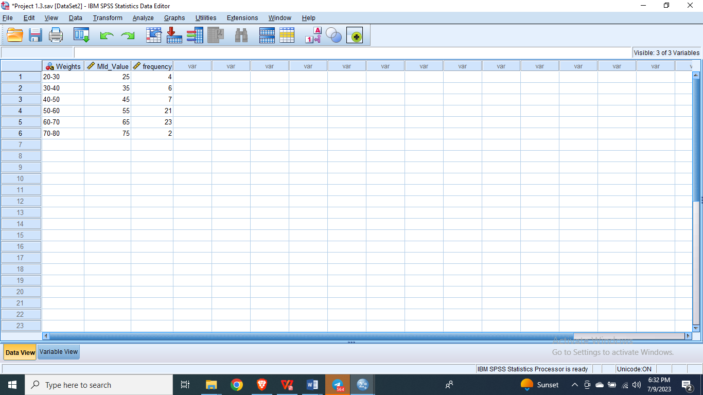



**Sampling Distribution and Estimation**

**Lab: 1 Date: 2080/02/29**

**Project 1.4:** CONFIDENCE INTERVAL FOR POPULATION MEAN μ, (σ UNKNOWN AND LARGE n)

**OBJECT:**

ENTER THE FOLLOWING VALUES IN SPSS AND CREAT A CONFIDENCE INTERVAL ASSUMING NORMAL DISTRUBUTION

LENGTH: 125, 120, 121, 123, 122, 130, 124, 122, 120, 122, 118, 119, 123, 124, 122, 124, 121, 122, 138, 149, 123, 128, 122. 130. 120, 122, 124, 134, 137, 128, 122, 121, 125, 120, 132, 130, 128, 130, 122, 124

**WORKING EXPRESSIONS:**

1. Mean (X) = $\frac{\sum{x}}{n}$
2. Median (Md) = $\frac{n+1}{2}$
3. Standard Deviation (S.D.) = $\sqrt{\frac{∑(X-X̅)2}{n}}$
4. Range = max – min
5. Mode = maximum repetition of data
6. Standard error (S.E.) = $\frac{S.D.}{\sqrt{n}}$
7. Confidence Interval (C.I.)= X $±Z\frac{S.D.}{\sqrt{n}}$

̅

Note: Where $\sum{x}$ represents the sum of all the items in the dataset and n represent the number of items in the given dataset.

**PROCESS:**

1. Enter the **data.**
2. Select **Analyze** **Compare Means** **One sample T test**
3. Click **Options** Type % (90, 95, 99)**confidence interval**
4. Click on **Continue** and then Click **Ok.**

**­­­­­**

**CALCULATION:**

From SPSS, the confidence interval after entering the given value in SPSS is:

|  |  |  |  |  |  |  |
| --- | --- | --- | --- | --- | --- | --- |
| **One-Sample Test** | | | | | | |
|  | Test Value = 0 | | | | | |
| t | df | Sig. (2-tailed) | Mean Difference | 95% Confidence Interval of the Difference | |
| Lower | Upper |
| Length | 128.879 | 39 | .000 | 125.275 | 123.31 | 127.24 |

**RESULT:**

Using SPSS, the confidence interval of the given data is 125.275, 127.4 at 95% confident level

**CONCLUSION:**

Hence, The confidence Interval for population mean was obtained by using One sample test in SPSS.